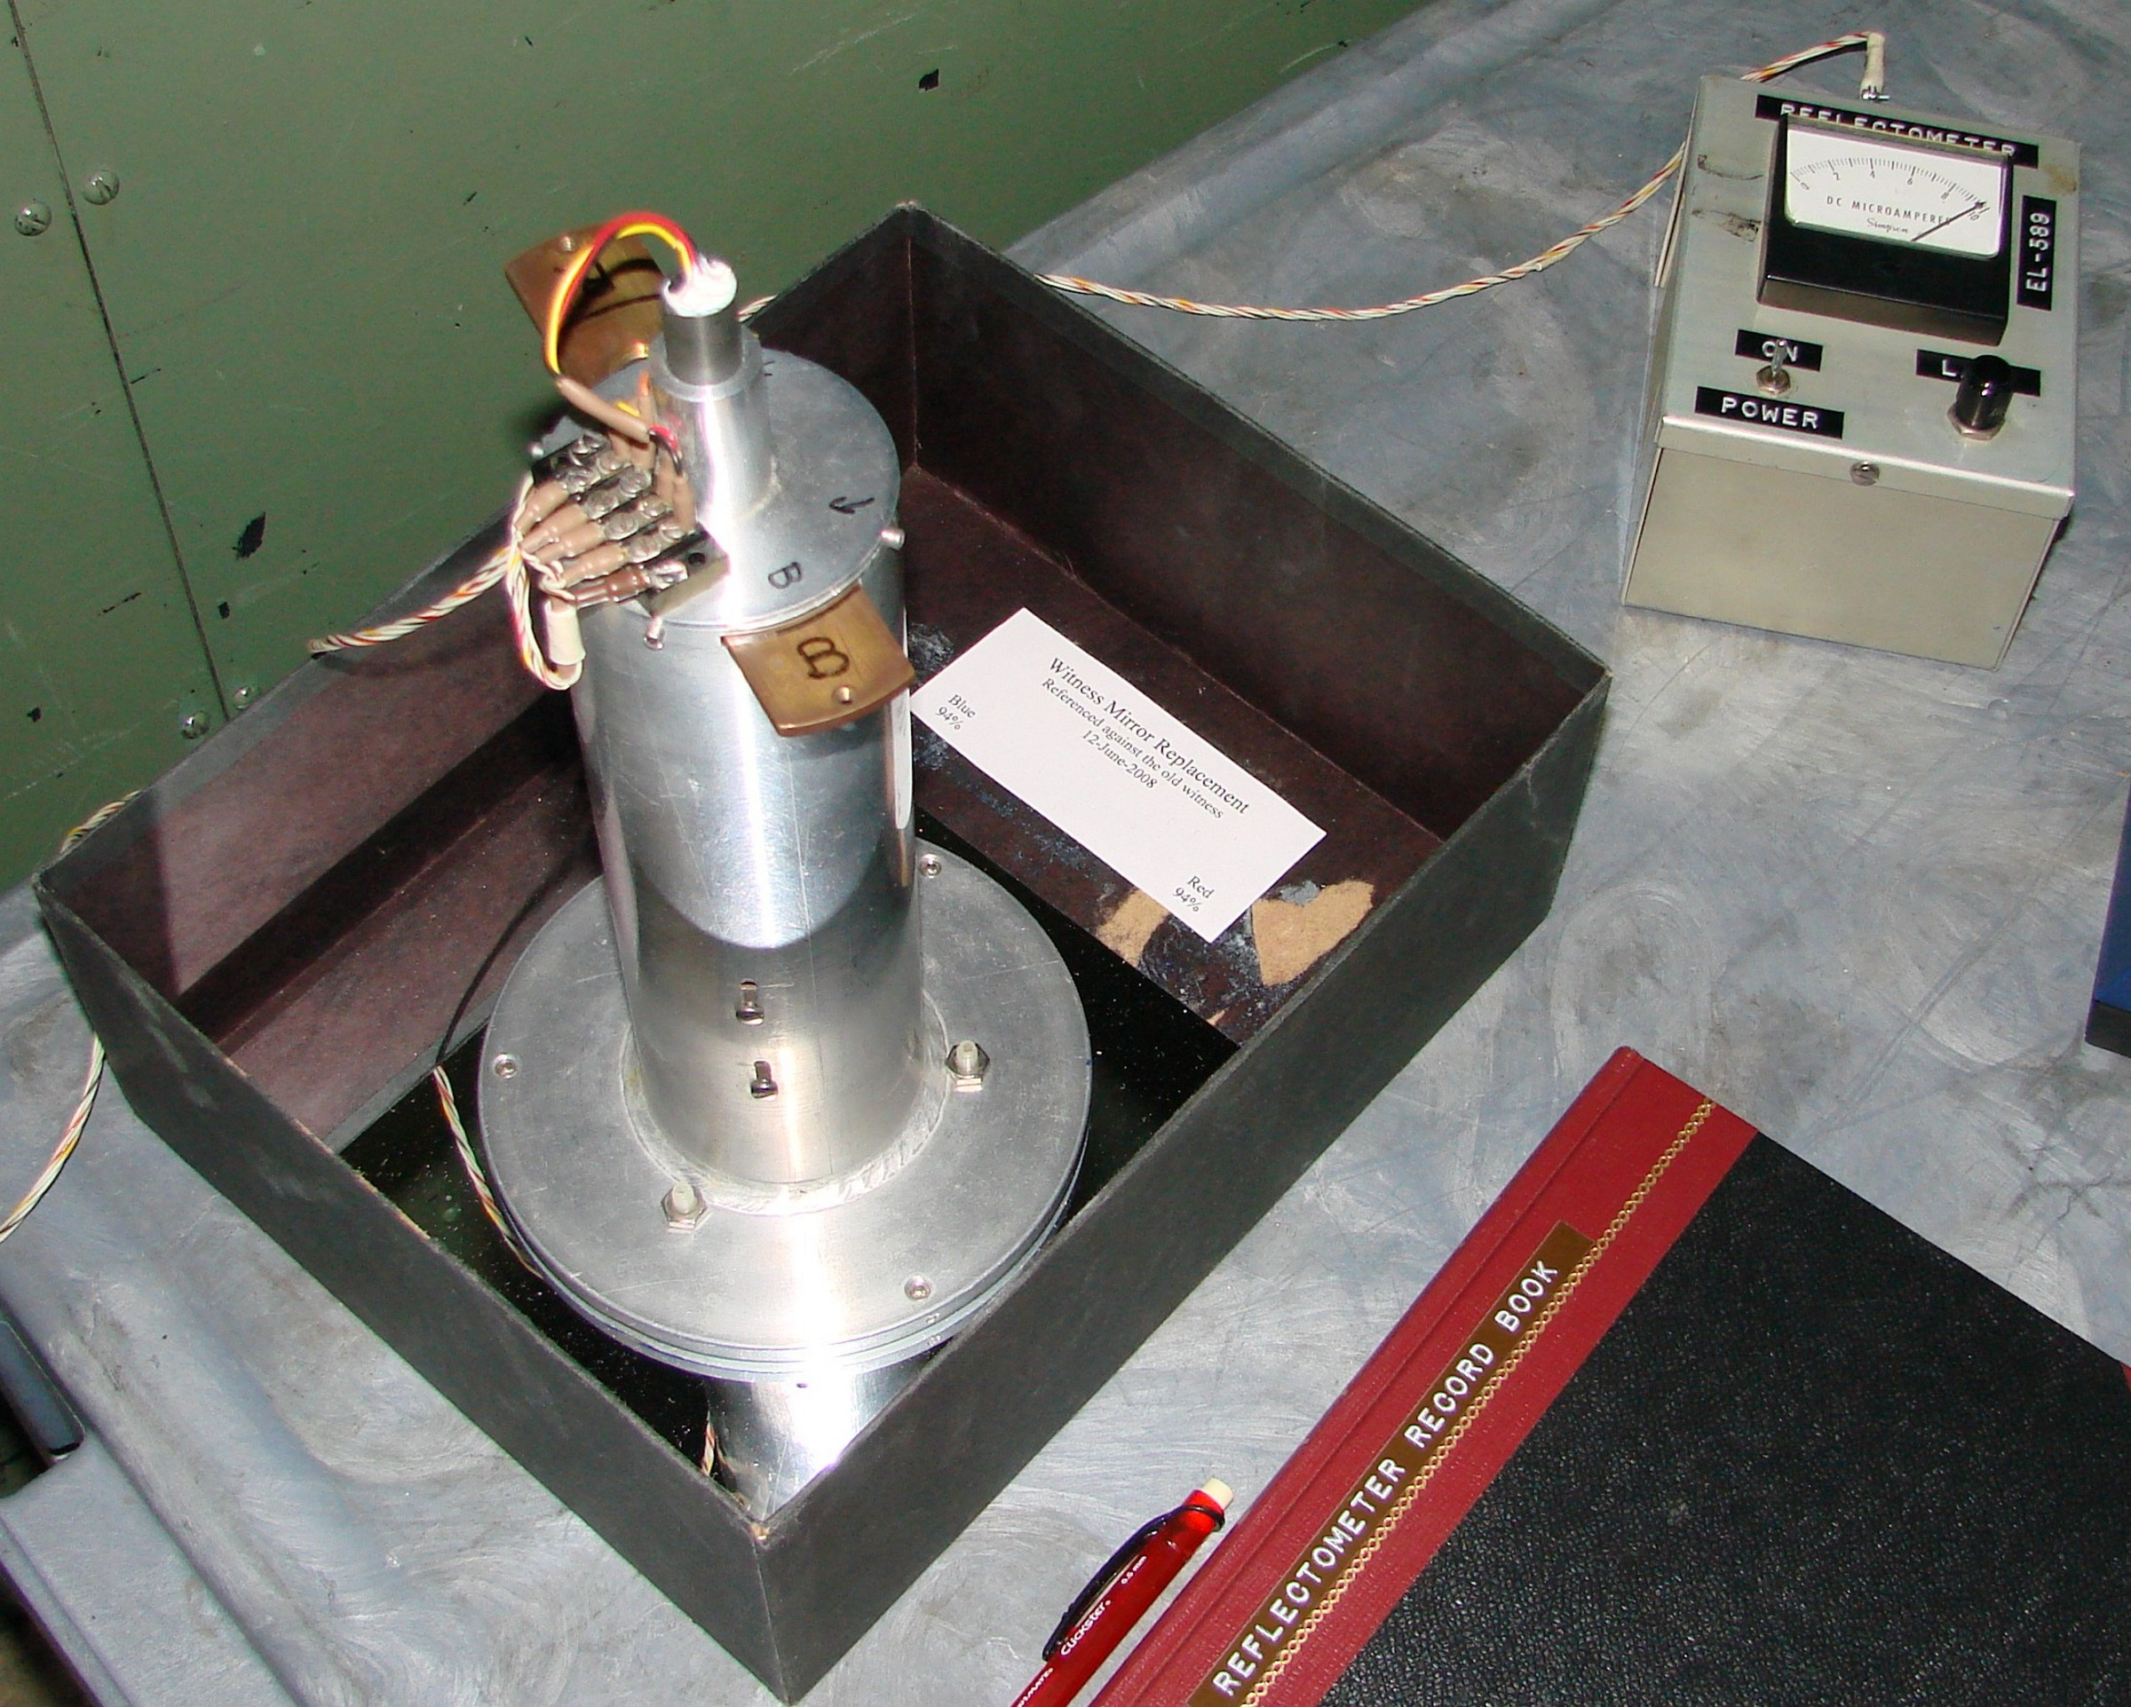

Introduction: This reflectometer is a “Lick built” instrument built many years ago and is fairly primitive. It is still good at comparing the coating to be tested against the quality of the witness mirror and is very easy to use.

Safety: There are no safety issues in the use of this devise.

Setting Up: The first thing to do after unpacking the reflectometer is to test the batteries.

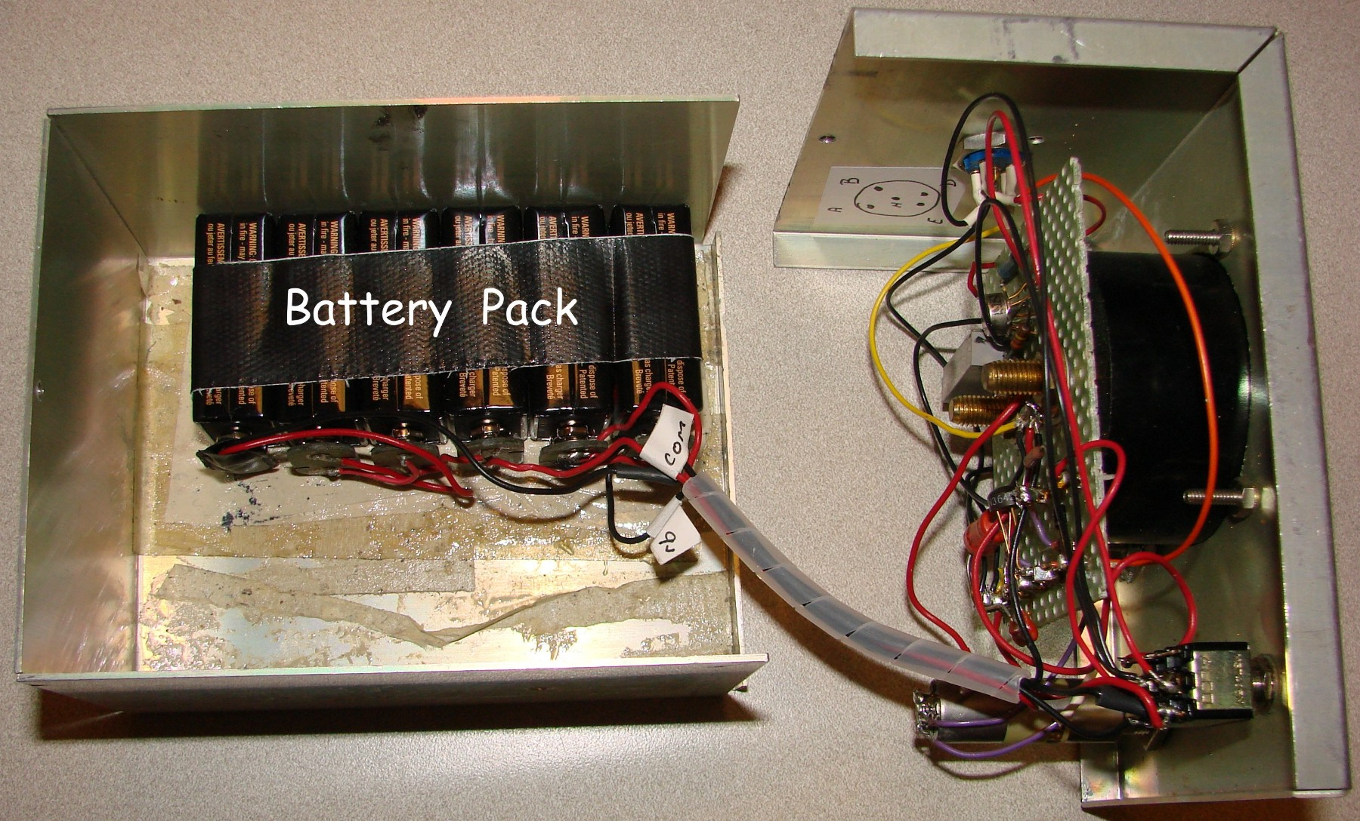

Turn on the unit with the sensor attached and sitting on the witness mirror. Place the sensor filter to Blue and using the knob labeled Lamp adjust the meter needle to 10. If the needle will not make it up to 10 replace the batteries. If while using the meter it continually drops while zeroing the meter, replace the batteries. Recycle the spent batteries properly.

The 9volt batteries are taped together to form a battery pack and held in place with double sided tape on the lid of the box. Replace all batteries at one time with fresh batteries.

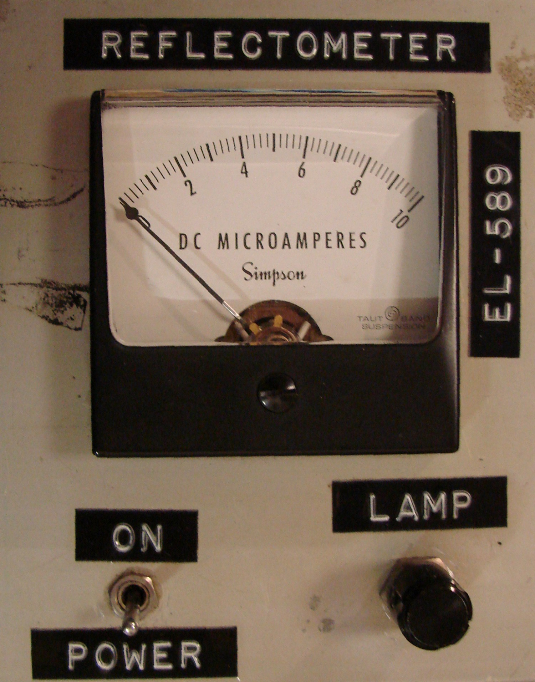
The instrument is quite simple to use. The electronics package has the power switch, lamp adjustment knob and meter.

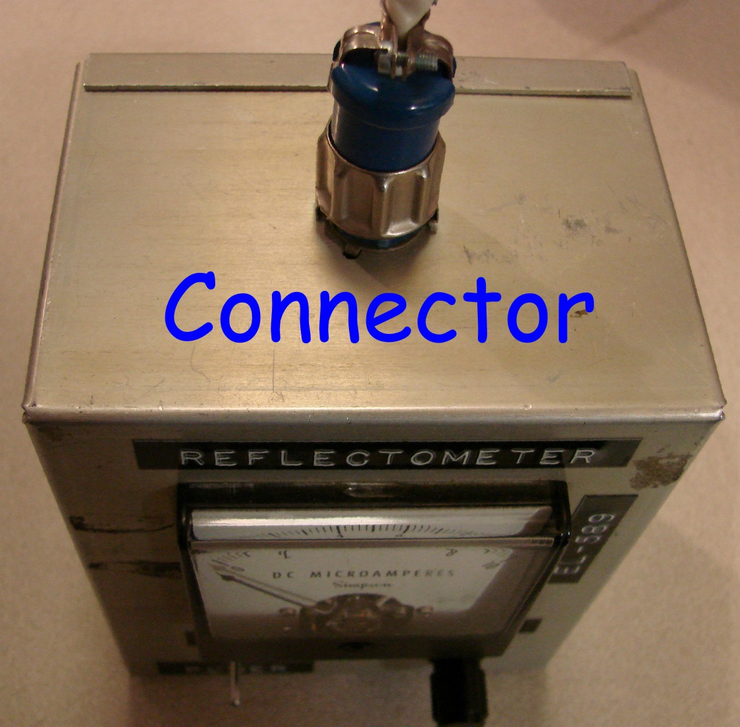

The sensor unit plugs into the top of the electronics box and the plug retainer is then locked into place to insure a good connection and the plug won’t fall out and drag across the optic being tested.

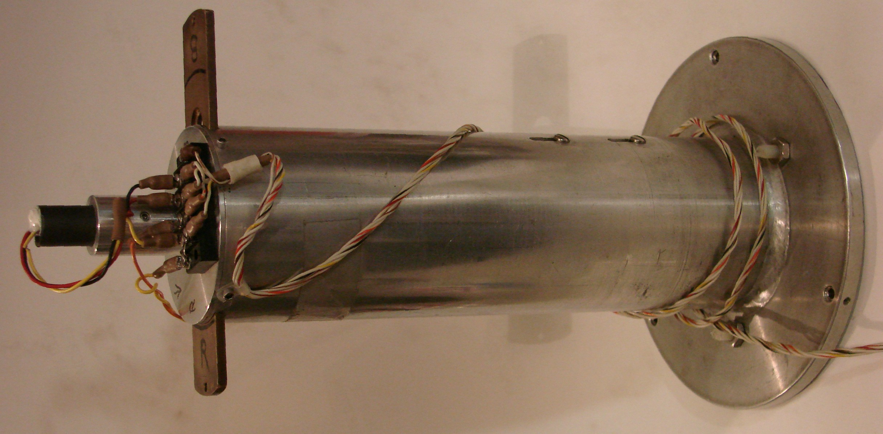

This is the sensor unit that is placed on the optic for testing. It has three small nylon feet that rest on the optic surface. These plastic feet help to reduce damage to the coating and optic. When placing the sensor use straight up and down motions only. Never slide the sensor on the optic surface as this would result in significant damage to the optic.

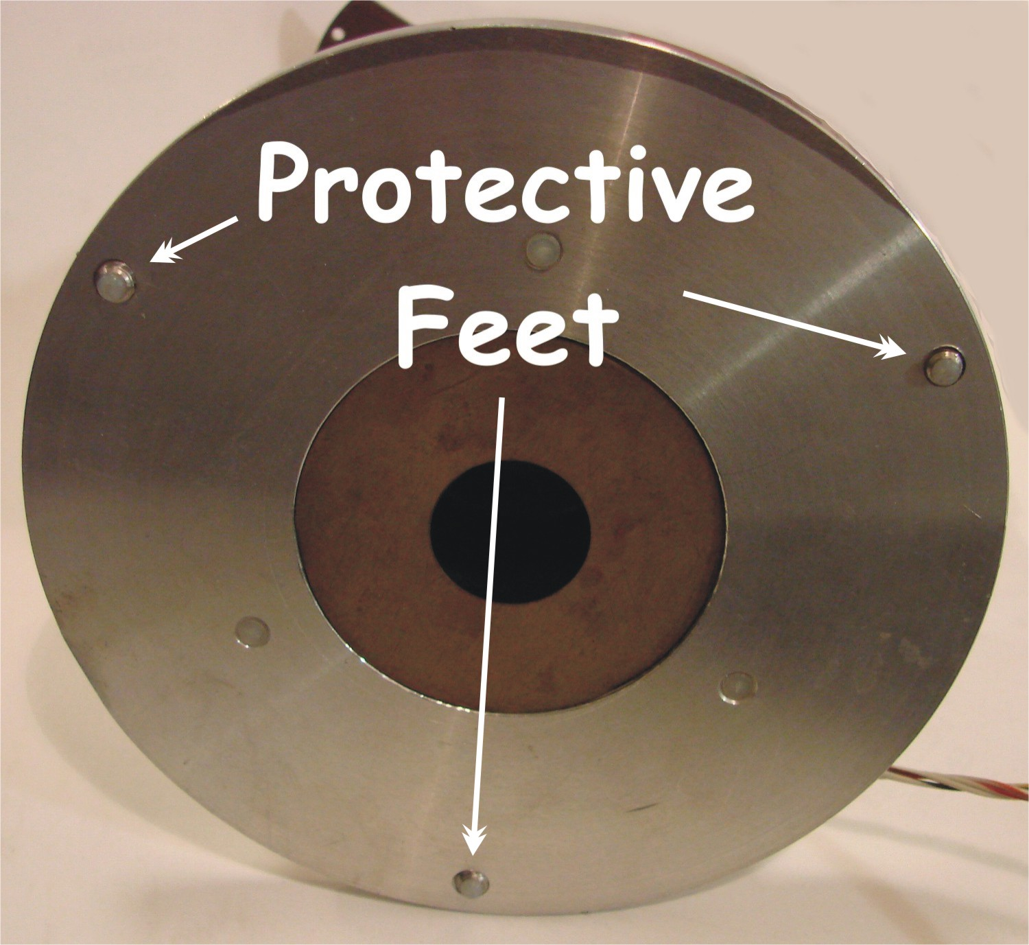
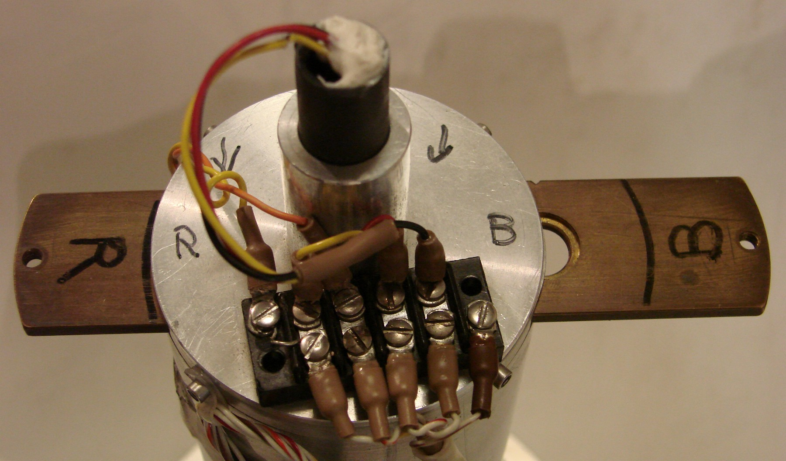
Filter Slide
On the top of the sensor is a brass filter slide that contains both red and blue filters. The slide is positioned by hand placing the filter in the detent for the color selected. There is also a black marker line to aid in finding the filter detent. The lamp is in the center snout with the three wires entering the dark plastic tube.

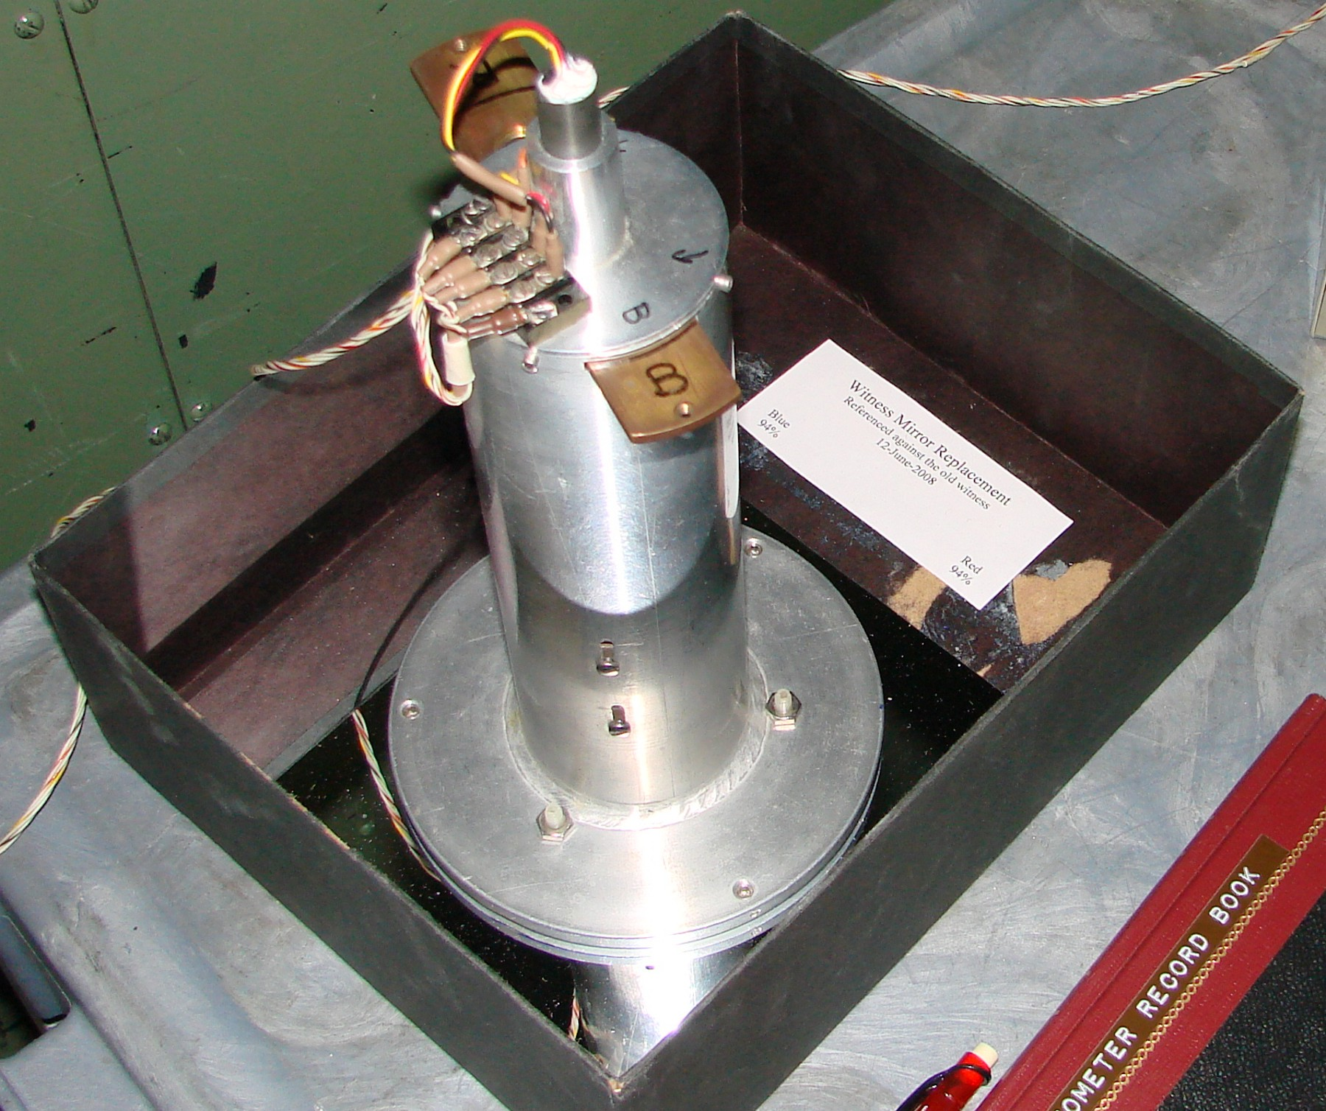
Use: Place the sensor on the witness and turn on the meter. Set the filter to the desired color. Adjust the meter to 10 on the meter. This represents 100% reflectivity of the witness. Now carefully lift the sensor and place it on the surface to be tested. Record the number displayed on the meter into the note book and return the sensor back to the witness and re-zero on the meter to 10. Then place the sensor on the next area to be tested. Do this several times for both red and blue then repack everything in the protective wrap and place back in the cabinet.

